Paige Deathe
C&T 762
December 10th, 2013
Tracking a Contemporary Issue – Student Debt Crisis

Activity 1
Students will be given an introduction of the topic, “Student Debt Crisis” by viewing a variety of political cartoons. Since the familiarity of the topic may be broad, students will be prompted with follow up questions.

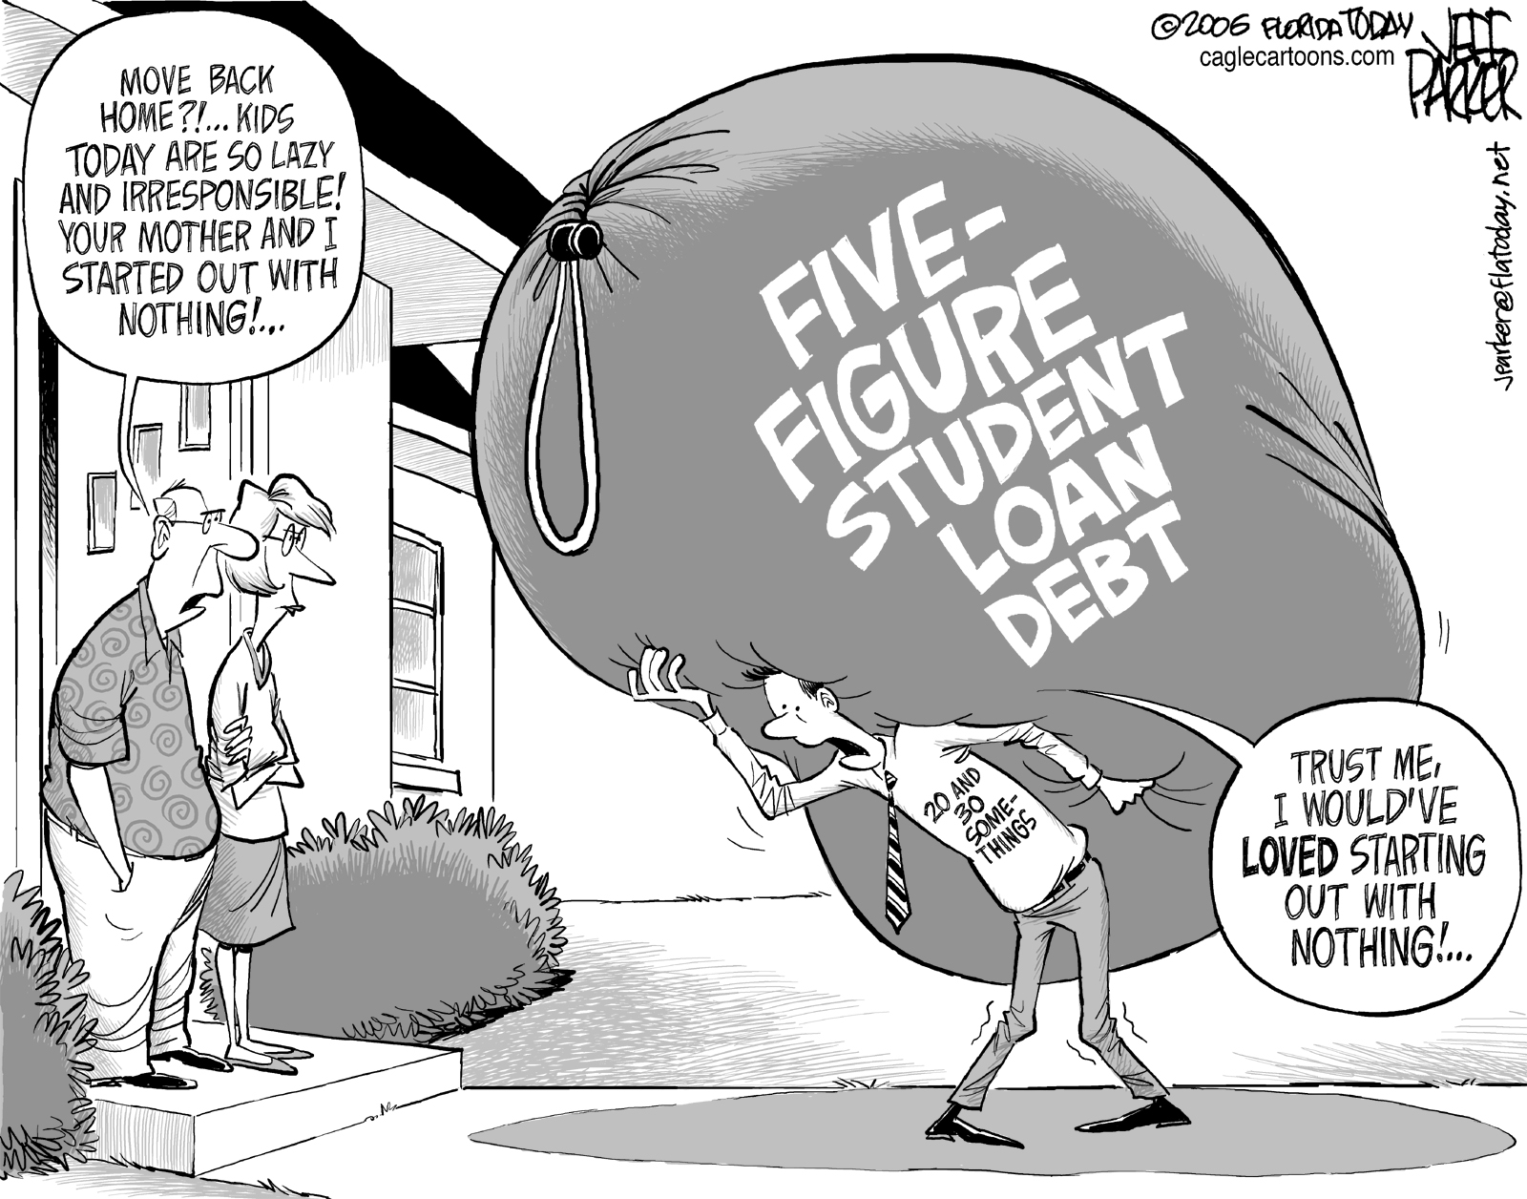

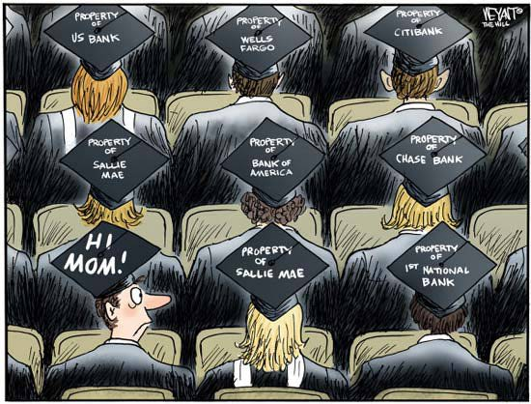
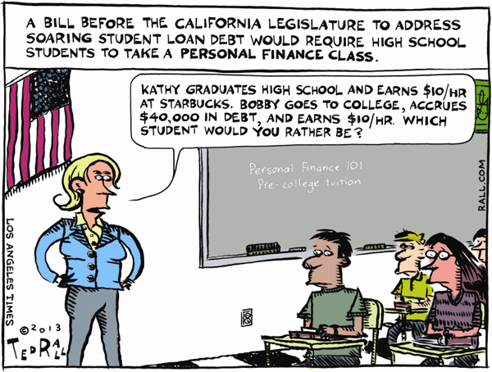

- What are key objects in each cartoon?
- What does each of these objects symbolize?
- What is the key message of the cartoon?
- Does the cartoon clearly convey its message to readers? Why or why not?
- What groups would agree/disagree with the cartoon?

Following the assignment, there will be a group discussion to gain awareness of student knowledge on the topic. Do they know anyone with student loans? Will they have student loans themselves?

Activity 2
In order to understand why student loan debt is an issue of concern to them, students will be looking at the average cost of college and average debt by student borrowers. Then, they will be analyzing the earning potential of those with various educational achievement levels. The main question to answer is, “Why are people going to college if they are going to be faced with a mountain of debt afterwards?” By comparing graphs, answer the following questions.

- What is the percent increase of a 4-year college from 1980-2010? 2-year college?
- What are the average student loan balances for 2005-2012?
- How is earning potential affected by education?
- Compare the earning potential from Adults Ages 25-34 with the Lifetime Earnings by Educational Achievement graphs. Are the results what you expected? More differences or less?
- If people are falling into debt and forced to pay outrageous prices for college, why are they still going?
- At what point, does attending college and accruing debt become worthless?
http://www.motherjones.com/politics/2013/06/student-loan-debt-charts
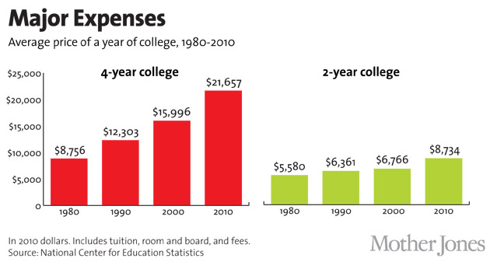
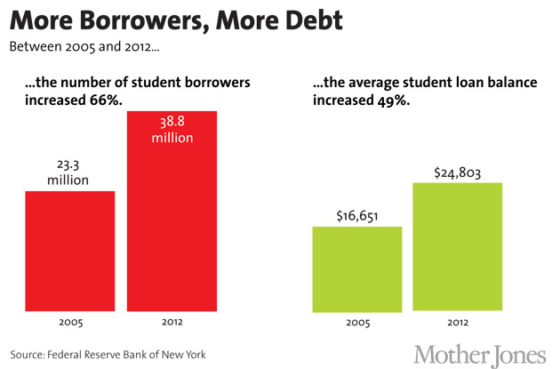

http://nces.ed.gov/fastfacts/display.asp?id=77
Adults Ages 25-34
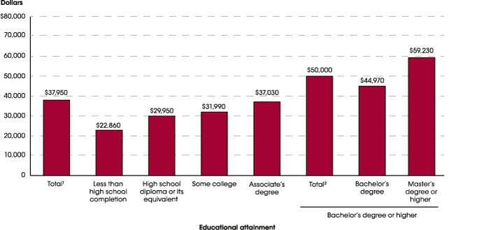
http://www9.georgetown.edu/grad/gppi/hpi/cew/pdfs/collegepayoff-complete.pdf

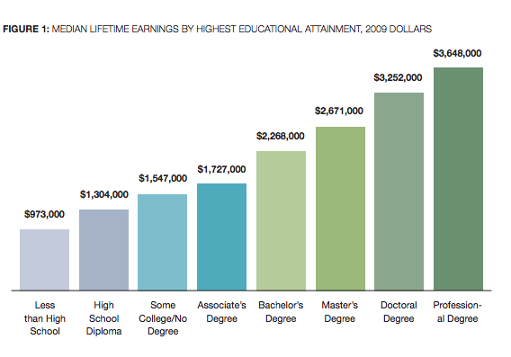

Activity 3
In activities 1&2, students have been introduced to the topic of student debt and how education plays a role in educational achievement. Today, they will be researching the historical roots of education in the United States, particularly higher education by looking at a document titled, “Opening the Doors to Higher Education: Perspectives on the Higher Education Act 40 Years Later.” This research provides a historical background on the United States and delves into the Higher Education Act (HEA). Half of the class will be developing online timelines with the key events that have been instrumental to developing our nation’s education system, up to the HEA. The other group will be creating a presentation on the HEA, keying in on implementation, goals, and successes/failures of the legislation. Students will look at each section or “title” of the HEA and present in small groups on their title using the Ning site to post and present their information.

http://www.tgslc.org/pdf/hea_history.pdf

Key events include (not shown to students but provided as answer key):
18th Century
- Settlers founding nine institutions of higher education including Harvard, Yale, William and Mary.
- Seminary Land Grants
- George Washington encouraged funding for a national university at the federal level but was never successful in convincing Congress

19th Century
- Morrill Act – gave states parcels of land to fund colleges
- Developed the Department of Education that focused on info relevant to teaching and learning as well as publishing research and statistics related to education at all levels
- Once Westward Expansion was complete, no federal initiatives for higher education would be implemented until the FDR administration

1900s – 1930s
- The College Board is founded in 1900 by a professor at Columbia University to make college admissions more uniform
- Woodrow Wilson becomes the first president to hold a doctorate degree
- The Bryn Mawr Summer School for women workers is opened in 1921; the goal being to educate working women
- During the Great Depression, the direct focus was on jobs instead of education. Roosevelt developed the National Youth Administration to help college students by providing funding for part time jobs

1940s – 1950s
- In 1942, GI Bill of Rights gave funding to service men and women (post WWII)
- The Truman Commission was developed in 1946 with the intention to make higher education in the U.S. more inclusive - results were mixed as access and segregation issues divided the panel
- The historic case, Brown vs. Board of Education, ends segregation in public schools in 1954
- In 1957, Sputnik is launched which increased education reform across the nation which led to the National Defense of Education Act
- The National Defense of Education Act of 1958 encouraged degrees in science and math while providing low-interest loans for college students and debt cancellation for future teachers

1960s
- The idea of the Great Society is introduced to politics by Lyndon B. Johnson, with the goal to equalize educational opportunities for all in the United States
- In 1965, the Elementary and Secondary Education Act (ESEA) is passed, putting $1 billion towards K-12 schools that were primarily low-income
- Following the ESEA, the Higher Education Act (HEA) is also passed which helped 46% of undergraduates pay for their education

The Higher Education Act (HEA) (key ideas to include)
- One of the most important pieces of the Great Society Legislation
- Instead of putting money in peoples’ pockets like Roosevelt did, LBJ believed the path to moving up in society was through education
- Several recommendations were included in the HEA through different “titles” (there were a total of 8) (page 18):
  - “Grants in aid to very able students who are among the most needy
  - Expansion of work-study programs
  - More extensive use of loans and loan guarantees
  - Opposition to tax credits for tuition and other educational expenses
  - Custom-made packages of aid that depended on a student’s needs
  - A scholarship program”
- Title I – Strengthening Community Service Programs
  - Provided grants to states with the goal of strengthening community service programs of colleges and universities
  - Research or continuing education could assist in solving urban and suburban issues including poverty, housing, transportation, and youth opportunities
- Title II – Assistance for Libraries
  - Provided grants for college books and materials
  - Increased number of college librarians and develop new techniques
- Title III – Developing Institutions
  - Gave aid to schools that were in the development stages such as African American schools in the South
  - Two-year colleges and technical institutions also received aid
- Title IV – Student Assistance Act
  - Authorized federal aid to students in the form of grants and loans for eligible full-time students
- Title V – Teacher Corps
  - Allocated special grants for those preparing to be teachers in elementary and high school
  - Recruited teachers for shortage areas
- Title VI – Undergraduate Instruction
  - Authorized money to postsecondary schools to purchase equipment
  - Enhanced faculty development and created awards for instructors to attend institutes and workshops
  - Gave money to institutions to develop international public policy centers
- Title VII – Higher Education Facilities
  - Initially provided funding for to build higher education facilities due to the baby boom
  - Currently, the focus has shifted to awards for graduate students in the humanities, arts, or social sciences.
  - Ensures that those with disabilities are guaranteed a quality education by providing the necessary educational services
- Title IV – Educational Opportunity Grants and the TRIO Program, Guaranteed Student Loans, Federal Work Study, and Perkins Loan Program
  - Gave grants to higher education institutions for first-year, full-time students up to four years
  - Creation of the TRIO programs (Upward Bound, Talent Search, Student Support Services) which sought to encourage and help disadvantage students attend college
  - Guaranteed student loans that were backed by the federal government (previously used the private sector for loans)
  - Updated the work-study program to be more education based by relating them to academics or community service
  - Provided low-interest loans to financially needy college students
  - Campuses control the dispersing of Perkins funds

Post HEA of 1965
- Reauthorizations occurred every 4-5 years, making minor changes each time
- Most of the main ideas of the HEA are still intact today

**Follow up activity on 2014 reauthorization of HEA will be conducted in a later lesson

Activity 4
As a follow up to the previous blog assignment, students are going to be making predictions about the 2014 Reauthorization of the Higher Education Act. In the presentations, students looked at the historical roots of the HEA and the actual goals and implementation of it. Today, we will be looking at what possible changes may occur and the issues brought to the table most recently. Students will post on the blog what their predictions are as well as their opinion on Obama’s plan to implement a college rating system. Is this good for the United States? Will it help or hinder those seeking a postsecondary education? Response should be a minimum of 2 pages, double-spaced. Be sure to include your predictions for the 2014 Reauthorization and thoughts on the college rating system. Use several resources to find information on the college rating system – remember, each source has its own opinion! Use several to formulate your own!

http://chronicle.com/article/What-You-Need-to-Know-About/141697/

http://www.insidehighered.com/news/2013/09/20/senate-education-committee-begins-process-reauthorization-higher-education-act

http://www.whitehouse.gov/the-press-office/2013/08/22/fact-sheet-president-s-plan-make-college-more-affordable-better-bargain-

http://www.usnews.com/education/best-colleges/articles/2013/11/13/colleges-skeptical-of-obamas-proposed-ratings

http://money.cnn.com/2013/08/22/pf/college/obama-college-ratings/

http://www.foxnews.com/politics/2013/08/22/obama-to-propose-new-system-for-rating-colleges/

Activity 5
First, students will view a video that details the different types of student aid offered by the federal government. Then, students will use the Federal Student Aid website to fill out a worksheet describing the various types of aid. This will allow students to see what options they have in paying for college and what types they will qualify for.

http://studentaid.ed.gov/types

Once students have completed the video and worksheet, they are going to compare 2012 graduate statistics at various institutions in Kansas. The statistics list the average debt, proportion of students with debt, number of bachelor’s degree recipients, cost of tuition, and the percentage of Pell Grant recipients. Once students have compared Kansas’ schools, they are to pick a different state/school and compare their statistics to Kansas. This will give an indication if the school provides grants and scholarships to students or they are forced to take out student loans.

http://projectonstudentdebt.org/state_by_state-view2013.php?area=KS

http://projectonstudentdebt.org/state_by_state-data.php?utm_source=twitter&utm_medium=social&utm_content=3107437

The link below gives the national averages of student debt and what areas have the highest and lowest debt by state.

http://projectonstudentdebt.org/files/pub/Student_Debt_and_the_Class_of_2012_NR.pdf

Activity 6
To wrap up the blog assignment, students will take a survey that will decide what they research. Based on their results, students will either do a career search with the Occupational Outlook Handbook (for high school education only) or compare the cost college by researching their top choice schools (those interested in college). Once they have picked a college, they will take a “What’s My Major Quiz” and search for occupations on the OOH. Looking at colleges, majors, and careers will give them an idea of expected tuition and salary. Additionally, they should use the PBS calculator to figure out whether or not they could work through school.

http://www.bls.gov/ooh/

http://www.luc.edu/undergrad/academiclife/whatsmymajorquiz/

http://www.pbs.org/newshour/multimedia/tuition-work/

Following Activity 6, students should submit a reaction paper with their intended goals following high school. They should include the statistics from their research and state whether or not they were surprised by the results. They also need to post their thoughts on the entire “Student Debt Crisis” and what they have learned. How is student debt going to affect them? What can the government do to fix this crisis? Is it the government’s job? There are several stances the students can take on the topic, but ideally they need to include their previous knowledge on student debt and their plans for the future.

